Nullpoint Studio Site Plan

Isaac Morley

WDD 130

Overview

Purpose

This website is about Nullpoint Studio, which is my independent developer brand, in which I design and build mobile apps. The recent app has been focused on Self Improvement and Personal Growth. The site will introduce the studio, show the apps I am building, and explain why I'm creating the apps to help people develop discipline, track progress, and improve their lives.

The website also serves as a central place where users can learn about my current projects, understand the purpose behind the apps, and follow the growth of Nullpoint Studio as I continue developing new software.

Audience
The audience for this website is people interested in self-improvement, discipline, habit building, and productivity tools. The audience also includes students, other developers, and technology enthusiasts who are interested in learning about independent software development and following the progress of projects being built under the Nullpoint Studio name.

Branding

Website Logo
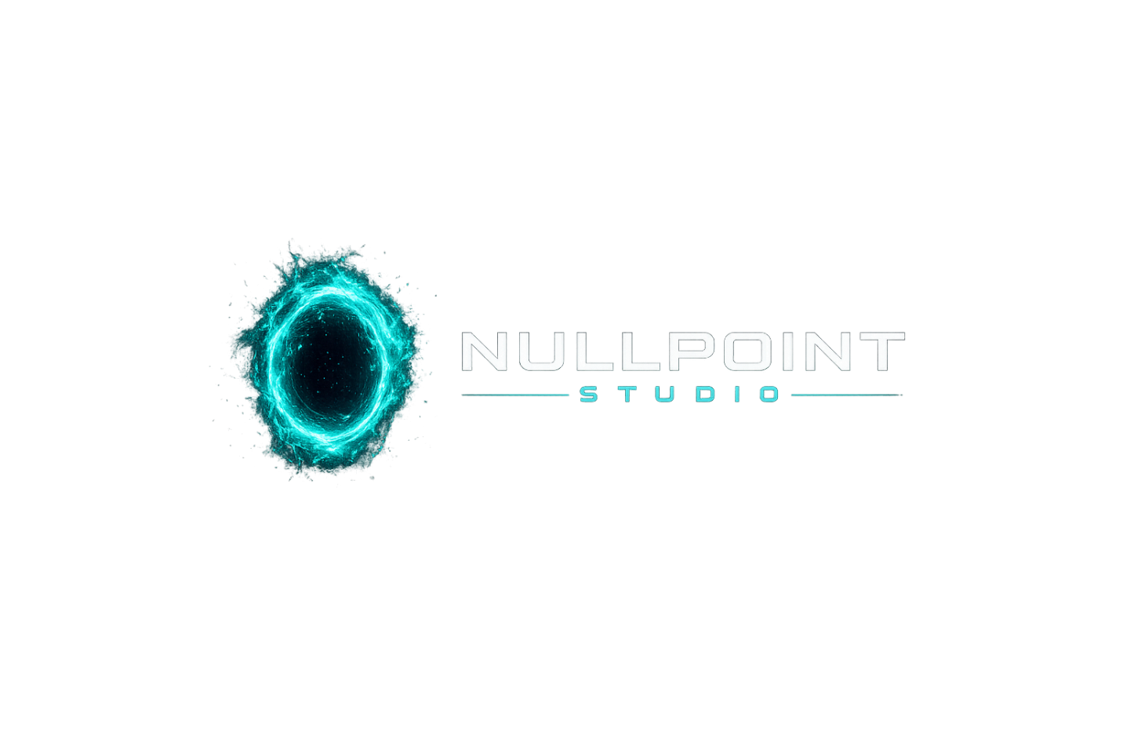

Style Guide

Color Palette
Primary | Secondary | Accent 1 | Accent 2
#070818 | #29FFC6 | #FFFFFF | #2C1B47

Typography

Heading Font: Orbitron

Paragraph Font: Roboto

The dark background combined with neon teal accents creates a modern technology aesthetic that fits the identity of a software studio. The high contrast between white text and the dark background also improves readability for users.

Navigation
Home Apps About

Content

Home Page
Page Purpose
The purpose of the homepage is to introduce visitors to Nullpoint Studio and explain what the studio builds.
Content
The homepage will begin with a hero section displaying the Nullpoint Studio logo and a short tagline such as “Mobile Apps for Self Improvement.”
Below the hero section, the page will introduce the mission of the studio and explain that the goal of Nullpoint Studio is to create software that helps people develop discipline and improve themselves.
The homepage will also highlight the main app currently being developed, including a screenshot and short description explaining its purpose.
Images
Nullpoint Studio logo
App interface screenshot
Technology themed background image

About Page
Page Purpose
The purpose of the About page is to explain what Nullpoint Studio is and the vision behind the studio.
Content
This page will describe why Nullpoint Studio was created and what the studio represents. It will explain that the studio is the name used for my independent development work and represents the apps and tools I create while continuing to grow as a developer.
The page will also explain the long term vision of building useful software that helps people stay disciplined, track progress, and improve themselves over time.
Images
Studio logo
Development themed images
Technology related visuals

Apps Page
Page Purpose
The purpose of the Apps page is to showcase the mobile applications created under Nullpoint Studio.
Content
This page will display the apps currently being developed. Each project will include a screenshot and a short explanation describing what the app does, the problem it solves, and how it helps users improve their habits or track progress.
Images
App screenshots
User interface previews
Visual elements demonstrating app features

Wireframes

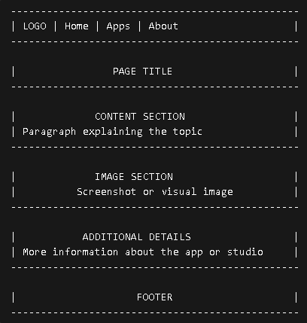
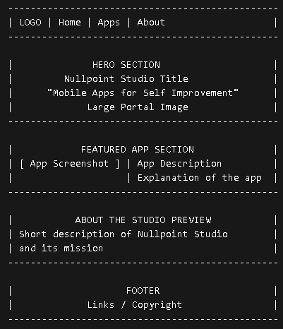
Home

